Discovered Host Screen:

After clicking “Provision”
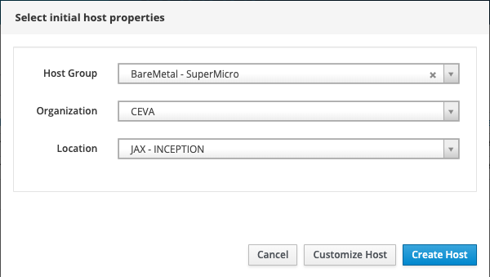
(at this point, the “Customize Host” and “Create Hosts” buttons do absolutely nothing.

After RE-Assigning the Organization and Location a SECOND time:
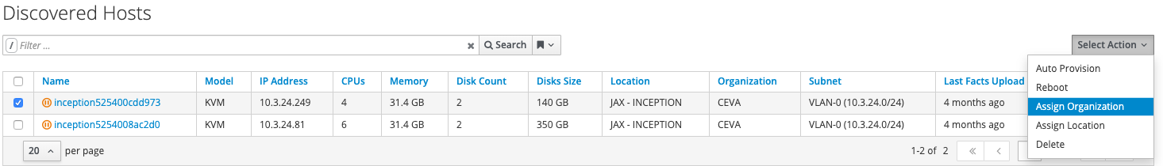
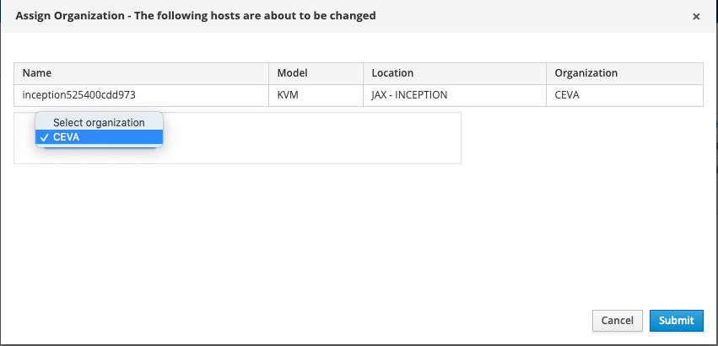
(repeating the above for the Location also)

Then, and ONLY then, can you use the “provision” button to Customize the Host before deployment. There is literally ZERO difference in the screens, and if you leave the screen and come back to the discovered hosts page again, you have to re-assign the Organization and Location AGAIN to get the “Customize Host” button to work again.

